

**Java Collections & Design Patterns**

Contents

Overview 3

Difference between list and set 3

Example: 3

Difference between Hashset and LinkedHashset 6

Example: 6

Difference between Vector and Arraylist 8

Example: 8

Difference between PriorityQueue and ArrayDeque 10

Example: 10

Apply factory pattern on Collections 14

Example 14

Apply Singleton pattern on Collections 18

Example 18

Cases to use factory session pattern 20

Task Management Application 20

Blog Management System 20

# Overview

This document is intended to provide java collections comparisons and how to apply factory pattern and singleton pattern on collections.

# Difference between list and set

|  |  |  |
| --- | --- | --- |
| **Feature** | **List** | **Set** |
| **Order of Elements** | Maintains the order of insertion (ordered). | Does not guarantee order (unordered). Some sets like LinkedHashSet maintain insertion order, and TreeSet sorts elements. |
| **Duplicates** | Allows duplicate elements. | Does not allow duplicate elements. |
| **Implementation Classes** | ArrayList, LinkedList, Vector. | HashSet, LinkedHashSet, TreeSet. |
| **Indexing** | Supports indexing (get(index) method). | Does not support indexing. You need to iterate to access elements. |
| **Performance** | Depends on the implementation. ArrayList provides fast random access but slower insertions/deletions. LinkedList has slower random access but faster insertions/deletions. | HashSet provides constant time O(1) for add, remove, and contains (on average). TreeSet has O(log n) due to sorting. |
| **Use Cases** | Use when order matters and duplicates are allowed. | Use when unique elements are needed and order is not critical (unless using LinkedHashSet or TreeSet). |

## Example:

**Java Code**

import java.util.*;

public class ListSetComparison {

public static void main(String[] args) {

// 1. Order of Elements

System.out.println("---- Order of Elements ----");

List<String> list = new ArrayList<>();

list.add("John");

list.add("Jane");

list.add("Jack");

list.add("Bob");

System.out.println("List (ArrayList) Order: " + list);

Set<String> set = new HashSet<>();

set.add("John");

set.add("Jane");

set.add("Jack");

set.add("Bob");

System.out.println("Set (HashSet) Order: " + set);

// 2. Duplicates

System.out.println("\n---- Duplicates ----");

list.add("John"); // List allows duplicates

System.out.println("List after adding duplicate 'John': " + list);

set.add("John"); // Set does not allow duplicates

System.out.println("Set after adding duplicate 'John': " + set);

// 3. Implementation Classes

System.out.println("\n---- Implementation Classes ----");

List<String> linkedList = new LinkedList<>();

linkedList.add("John");

linkedList.add("Jane");

linkedList.add("Jack");

linkedList.add("Bob");

System.out.println("LinkedList (List Implementation): " + linkedList);

Set<String> treeSet = new TreeSet<>();

treeSet.add("John");

treeSet.add("Jane");

treeSet.add("Jack");

treeSet.add("Bob");

System.out.println("TreeSet (Set Implementation): " + treeSet);

// 4. Indexing

System.out.println("\n---- Indexing ----");

System.out.println("List (ArrayList) Access by Index: " + list.get(0)); // Access by index

// Set does not support indexing, so we can't do something like set.get(0)

System.out.println("Set does not support indexing.You must iterate through the Set to access elements");

System.out.println("Iterating over the Set:");

for (String element : set) {

System.out.println(element);

}

// 5. Use Cases

System.out.println("\n---- Use Cases ----");

System.out.println("Use a List when order matters and duplicates are allowed.");

System.out.println("Use a Set when you need unique elements, and order is not important (unless using LinkedHashSet or TreeSet).");

}

}

**Output:**

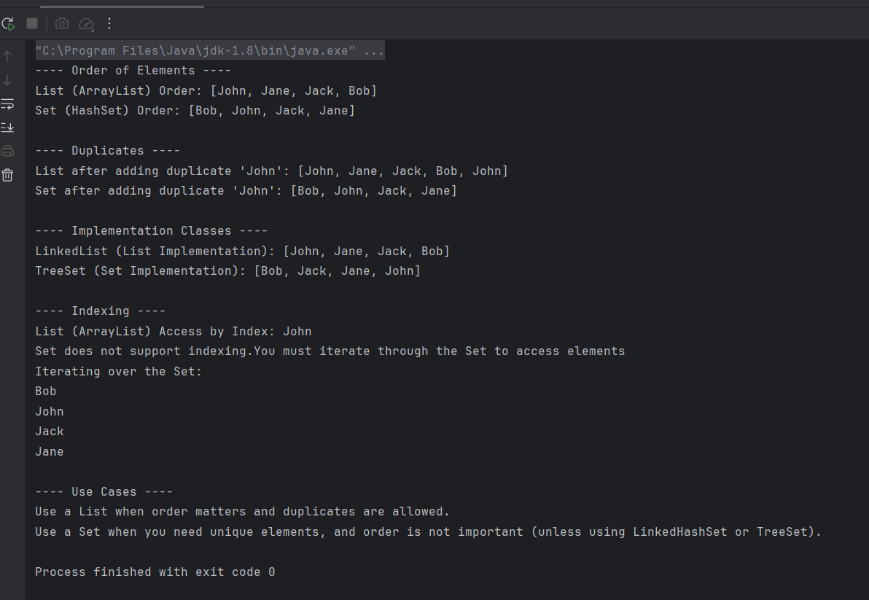

# Difference between Hashset and LinkedHashset

|  |  |  |
| --- | --- | --- |
| **Feature** | **HashSet** | **LinkedHashSet** |
| **Order of Elements** | Does not maintain any specific order. The order of elements is not predictable. | Maintains the insertion order (the order in which elements are added). |
| **Implementation** | Implements **Set** and uses a hash table to store elements. | Extends **HashSet** and uses a linked list in addition to a hash table to maintain insertion order. |
| **Performance** | Slightly faster for insertions and lookups because it doesn't maintain order. | Slightly slower than HashSet due to the overhead of maintaining insertion order. |
| **Iteration Order** | Iteration order is not guaranteed and may vary. | Iteration order is predictable and follows the order of insertion. |
| **Use Case** | Best when order does not matter and fast operations (add, remove, contains) are required. | Best when you need to maintain the order of insertion of elements while ensuring uniqueness. |
| **Memory Overhead** | Lower memory overhead compared to LinkedHashSet. | Higher memory overhead due to the additional linked list for maintaining order |

## Example:

**Java Code**

import java.util.HashSet;  
import java.util.LinkedHashSet;  
import java.util.Set;  
  
public class HashSetVsLinkedHashSet {  
 public static void main(String[] args) {  
 // 1. Order of Elements: HashSet does not guarantee order, LinkedHashSet maintains insertion order.  
 System.*out*.println("---- Order of Elements ----");  
 // HashSet Example (No Order Guarantee)  
 Set<String> hashSet = new HashSet<>();  
 hashSet.add("John");  
 hashSet.add("Jane");  
 hashSet.add("Jack");  
 hashSet.add("Bob");  
 System.*out*.println("HashSet (No order guarantee):");  
 for (String element : hashSet) {  
 System.*out*.println(element);  
 }  
 // LinkedHashSet Example (Maintains Insertion Order)  
 Set<String> linkedHashSet = new LinkedHashSet<>();  
 linkedHashSet.add("John");  
 linkedHashSet.add("Jane");  
 linkedHashSet.add("Jack");  
 linkedHashSet.add("Bob");  
 System.*out*.println("LinkedHashSet (Maintains Insertion Order):");  
 for (String element : linkedHashSet) {  
 System.*out*.println(element);  
 }  
  
 System.*out*.println("\n---- Duplicates ----");  
 // 2. Duplicates: Both HashSet and LinkedHashSet do not allow duplicates  
 hashSet.add("John"); // Adding duplicate "John"  
 System.*out*.println("HashSet after adding duplicate 'John': " + hashSet); // Duplicates are not added  
  
 linkedHashSet.add("John"); // Adding duplicate "John"  
 System.*out*.println("linkedHashSet after adding duplicate 'John': " + linkedHashSet); // Duplicates are not added  
  
 System.*out*.println("\n---- Memory overhead ----");  
 // 3. Memory Overhead: LinkedHashSet has a higher memory overhead  
 System.*out*.println("Memory overhead: LinkedHashSet requires more memory due to maintaining insertion order.");  
 }  
}

**Output:**

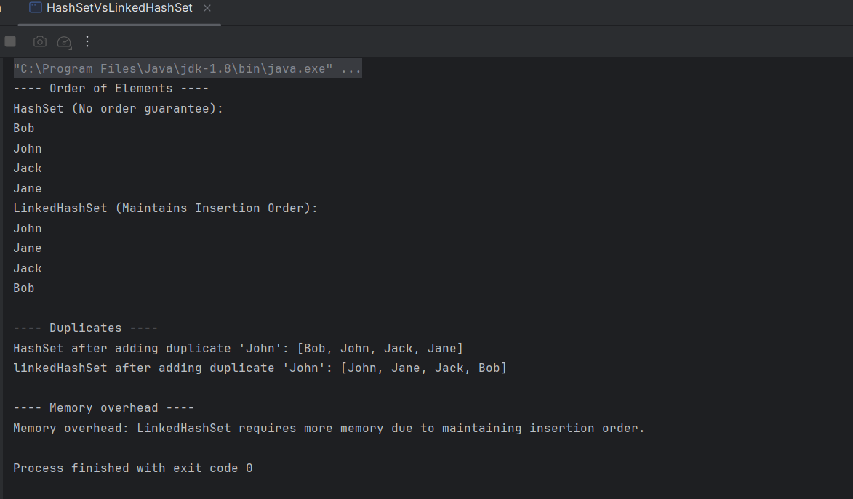

# Difference between Vector and Arraylist

|  |  |  |
| --- | --- | --- |
| **Feature** | **Vector** | **ArrayList** |
| **Thread Safety** | **Thread-safe** (synchronized methods). | **Not thread-safe** (not synchronized by default). |
| **Growth Behavior** | Doubles its size when it runs out of space. | Grows by 50% of its size when it runs out of space. |
| **Performance** | Slower than ArrayList due to synchronization. | Faster than Vector because it's not synchronized. |
| **Capacity Increment** | Can be set manually, defaults to doubling size. | Default increment is 50% of the current size. |
| **Use Case** | Suitable for multi-threaded environments where thread safety is needed. | Suitable for single-threaded applications where performance is more critical. |

## Example:

import java.util.ArrayList;

import java.util.Vector;

public class VectorVsArrayList {

public static void main(String[] args) {

// 1. Vector Example (Thread-safe, slower due to synchronization)

Vector<String> vector = new Vector<>();

vector.add("John");

vector.add("Jane");

vector.add("Jack");

vector.add("Bob");

System.out.println("Vector Elements:");

for (String element : vector) {

System.out.println(element);

}

// 2. ArrayList Example (Not thread-safe, faster)

ArrayList<String> arrayList = new ArrayList<>();

arrayList.add("John");

arrayList.add("Jane");

arrayList.add("Jack");

arrayList.add("Bob");

System.out.println("\nArrayList Elements:");

for (String element : arrayList) {

System.out.println(element);

}

// 3. Capacity Growth Behavior Comparison

Vector<String> vectorWithInitialCapacity = new Vector<>(2);

vectorWithInitialCapacity.add("John");

vectorWithInitialCapacity.add("Jane");

vectorWithInitialCapacity.add("Jack"); // Will cause resize

System.out.println("\nVector with Initial Capacity of 2 after resize:");

System.out.println("Size: " + vectorWithInitialCapacity.size());

System.out.println("Capacity: " + vectorWithInitialCapacity.capacity());

// ArrayList with initial capacity of 2 (will grow by 50% when exceeded)

ArrayList<String> arrayListWithInitialCapacity = new ArrayList<>(2);

arrayListWithInitialCapacity.add("John");

arrayListWithInitialCapacity.add("Jane");

arrayListWithInitialCapacity.add("Jack"); // Will cause resize

System.out.println("\nArrayList with Initial Capacity of 2 after resize:");

System.out.println("Size: " + arrayListWithInitialCapacity.size());

System.out.println("Capacity: " + arrayListWithInitialCapacity.size());

}

}

**Output:**

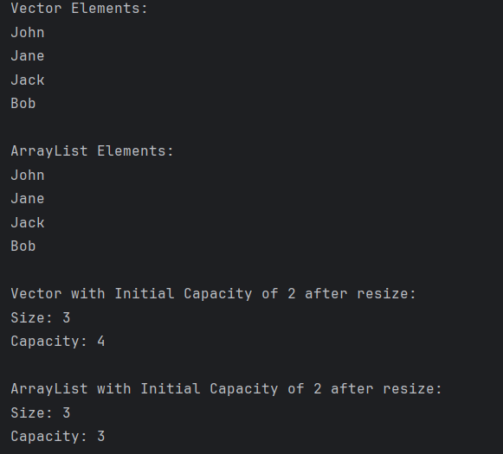

# Difference between PriorityQueue and ArrayDeque

|  |  |  |
| --- | --- | --- |
| **Feature** | **PriorityQueue** | **ArrayDeque** |
| **Purpose** | Implements a priority queue where elements are ordered based on their priority. The order is determined by the natural ordering of the elements or by a comparator. | Implements a double-ended queue (Deque), which allows elements to be added or removed from both ends (front and back). |
| **Ordering** | Elements are ordered based on priority (default is natural ordering or using a comparator). | Elements are ordered based on the order in which they were inserted (FIFO: First-In-First-Out). |
| **Use Case** | Best suited for managing elements based on their priority (e.g., task scheduling, Huffman encoding). | Best suited for use cases where you need efficient insertion and removal from both ends of the queue (e.g., deque, stack, queue). |
| **Performance** | Provides **O(log n)** time complexity for insertions and deletions (due to the underlying heap structure). | Provides **O(1)** time complexity for adding/removing elements from either end (front or back). |
| **Access to Elements** | Only the element with the highest priority can be accessed in constant time (peek() or poll() for the highest priority). | Accessing elements from both ends is possible (peekFirst(), peekLast(), pollFirst(), pollLast()), but not based on priority. |

## Example:

import java.util.ArrayDeque;

import java.util.PriorityQueue;

public class PriorityQueueVsArrayDeque {

public static void main(String[] args) {

// 1. PriorityQueue Example (Ordered by priority)

//System.out.println("PriorityQueue (Ordered by priority):");

PriorityQueue<String> priorityQueue = new PriorityQueue<>();

priorityQueue.add("John");

priorityQueue.add("Jane");

priorityQueue.add("Jack");

priorityQueue.add("Bob");

System.out.println("PriorityQueue elements (by priority):");

while (!priorityQueue.isEmpty()) {

System.out.println(priorityQueue.poll()); // Polls the element with the highest priority

}

// 2. ArrayDeque Example (FIFO Order, operations on both ends)

// System.out.println("\nArrayDeque (FIFO order, both ends accessible):");

ArrayDeque<String> arrayDeque = new ArrayDeque<>();

arrayDeque.add("John");

arrayDeque.add("Jane");

arrayDeque.add("Jack");

arrayDeque.add("Bob");

System.out.println("\nArrayDeque elements (FIFO order):");

for (String element : arrayDeque) {

System.out.println(element);

}

// Access the first and last elements

System.out.println("\nFirst element: " + arrayDeque.peekFirst()); // "John"

System.out.println("Last element: " + arrayDeque.peekLast()); // "Bob"

// Remove from front and back

System.out.println("\nRemove first element: " + arrayDeque.pollFirst()); // Removes "John"

System.out.println("Remove last element: " + arrayDeque.pollLast()); // Removes "Bob"

// Remaining elements in ArrayDeque

System.out.println("\nRemaining elements in ArrayDeque (FIFO):");

for (String element : arrayDeque) {

System.out.println(element);

}

// 3. Duplicates: Both allow duplicates

System.out.println("\nAllowing duplicates in both collections:");

PriorityQueue<String> pqWithDuplicates = new PriorityQueue<>();

pqWithDuplicates.add("John");

pqWithDuplicates.add("Jane");

pqWithDuplicates.add("Jack");

pqWithDuplicates.add("Bob");

pqWithDuplicates.add("Jack"); // Duplicate

System.out.println("PriorityQueue with duplicates:");

while (!pqWithDuplicates.isEmpty()) {

System.out.println(pqWithDuplicates.poll()); // Duplicates will be present

}

ArrayDeque<String> dequeWithDuplicates = new ArrayDeque<>();

dequeWithDuplicates.add("John");

dequeWithDuplicates.add("Jane");

dequeWithDuplicates.add("Jack");

dequeWithDuplicates.add("Bob");

dequeWithDuplicates.add("Jack");

System.out.println("\nArrayDeque with duplicates:");

for (String element : dequeWithDuplicates) {

System.out.println(element); // Duplicates will be present

}

// 4. Capacity Management:

// PriorityQueue doesn't manage capacity explicitly; it grows dynamically.

// ArrayDeque grows automatically, starting from a default size (16) and doubling when needed.

// Example of ArrayDeque's initial capacity and growth:

System.out.println("\nArrayDeque initial capacity and growth:");

ArrayDeque<String> dequeWithCapacity = new ArrayDeque<>(2); // Initial capacity of 2

dequeWithCapacity.add("John");

dequeWithCapacity.add("Jane");

dequeWithCapacity.add("Jack"); // Will cause resize

System.out.println("Size after adding elements: " + dequeWithCapacity.size());

}

}

**Output:**

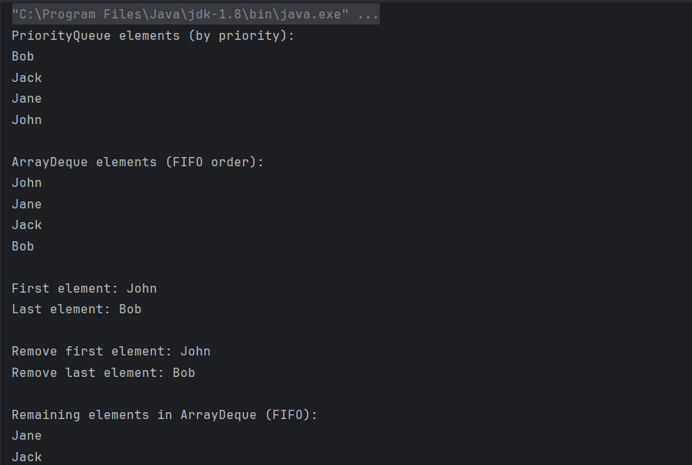

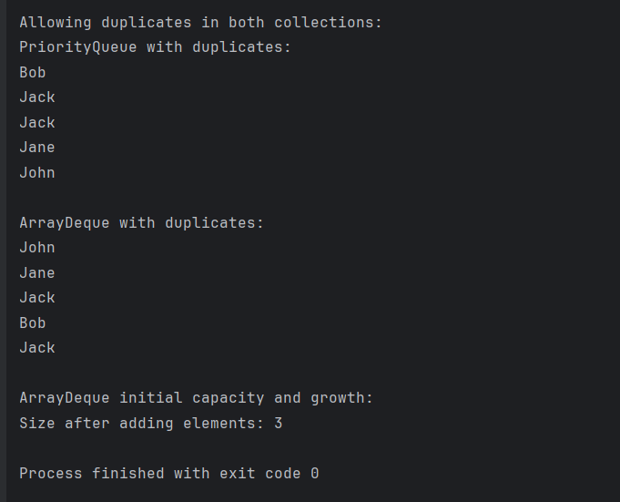

# Apply factory pattern on Collections

You can use this CollectionFactory class to create any collection, as long as you provide the fully qualified name of the collection class (e.g., "java.util.ArrayList", "java.util.LinkedList", etc.).

## Example

import java.lang.reflect.InvocationTargetException;

import java.util.Collection;

public class CollectionFactory {

public static <T> Collection<T> getCollection(String type){

Class<?> collection;

try {

collection = Class.forName(type);

try {

return (Collection<T>)collection.getDeclaredConstructor().newInstance();

} catch (InstantiationException e) {

throw new RuntimeException(e);

} catch (IllegalAccessException e) {

throw new RuntimeException(e);

} catch (InvocationTargetException e) {

throw new RuntimeException(e);

} catch (NoSuchMethodException e) {

throw new RuntimeException(e);

}

} catch (ClassNotFoundException e) {

throw new RuntimeException(e);

}

}

}

**List Implementation:**

You can use this ListImplement class to demonstrates how to use the CollectionFactory class to create various types of Collection objects, such as ArrayList, LinkedList, Vector, and Stack.

import java.util.Collection;

import java.util.Vector;

public class ListImplement {

public static void main(String[] args) {

// Create an ArrayList using the factory

Collection<Object> arrayList = CollectionFactory.getCollection("java.util.ArrayList");

arrayList.add("Item 1");

arrayList.add("Item 2");

System.out.println("ArrayList: " + arrayList);

// Create a LinkedList using the factory

Collection<Object> linkedList = CollectionFactory.getCollection("java.util.LinkedList");

linkedList.add("Item A");

linkedList.add("Item B");

System.out.println("LinkedList: " + linkedList);

// Create a Vector using the factory

Collection<Object> vector = CollectionFactory.getCollection("java.util.Vector");

vector.add("Item X");

vector.add("Item Y");

System.out.println("Vector: " + vector);

// Create a Stack using the factory

Collection<Object> stack = CollectionFactory.getCollection("java.util.Stack");

stack.add("Item 10");

stack.add("Item 20");

System.out.println("Stack: " + stack);

}

}

**Output:**

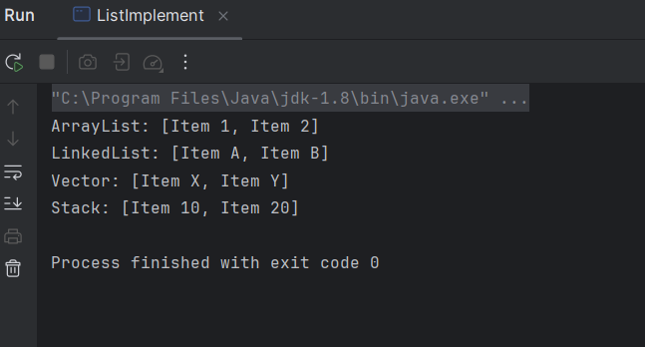

**Queue Implementation:**

You can use this QueueImplement class to demonstrates how to use the CollectionFactory class to create various types of Collection objects, such as PriorityQueue and ArrayDeque.

import java.util.Collection;

public class QueueImplement {

public static void main(String[] args) {

// Create a PriorityQueue using the factory

Collection<Object> priorityQueue = CollectionFactory.getCollection("java.util.PriorityQueue");

priorityQueue.add("Item 1");

priorityQueue.add("Item 2");

System.out.println("PriorityQueue: " + priorityQueue);

// Create an ArrayDeque using the factory

Collection<Object> arrayDeque = CollectionFactory.getCollection("java.util.ArrayDeque");

arrayDeque.add("Item A");

arrayDeque.add("Item B");

System.out.println("ArrayDeque: " + arrayDeque);

}

}

**Output:**

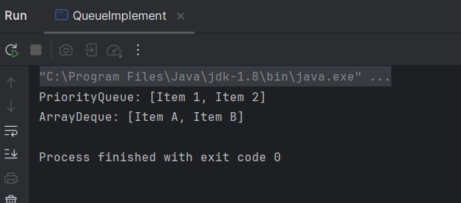

**Set Implementation:**

You can use this SetImplement class to demonstrates how to use the CollectionFactory class to create various types of Collection objects, such as HashSet, LinkedHashSet and TreeSet.

import java.util.Collection;

public class SetImplement {

public static void main(String[] args) {

// Create a HashSet using the factory

Collection<Object> hashSet = CollectionFactory.getCollection("java.util.HashSet");

hashSet.add("Item 1");

hashSet.add("Item 2");

System.out.println("HashSet: " + hashSet);

// Create a LinkedHashSet using the factory

Collection<Object> linkedHashSet = CollectionFactory.getCollection("java.util.LinkedHashSet");

linkedHashSet.add("Item A");

linkedHashSet.add("Item B");

System.out.println("LinkedHashSet: " + linkedHashSet);

// Create a TreeSet using the factory

Collection<Object> treeSet = CollectionFactory.getCollection("java.util.TreeSet");

treeSet.add("Item X");

treeSet.add("Item Y");

System.out.println("TreeSet: " + treeSet);

}

}

**Output:**

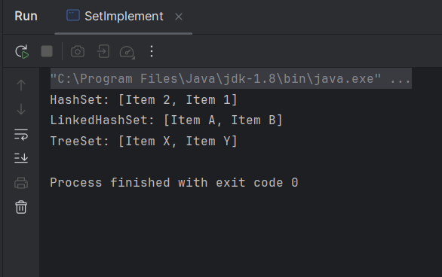

# Apply Singleton pattern on Collections

You can use this SingletonCollection class to create create a **singleton list** where only one instance of the list is used throughout the application.

## Example

import java.util.ArrayList;

import java.util.List;

public class SingletonCollection {

// Step 1: Private static instance of the collection

private static List<String> uniqueList;

// Step 2: Private constructor to prevent instantiation from other classes

private SingletonCollection() {

uniqueList = new ArrayList<>();

}

// Step 3: Public static method to get the instance of the collection

public static List<String> getInstance() {

if (uniqueList == null) {

// Lazy initialization of the collection

uniqueList = new ArrayList<>();

}

return uniqueList;

}

// Additional method to add elements to the collection

public static void addItem(String item) {

getInstance().add(item);

}

// Additional method to get the collection size

public static int getSize() {

return getInstance().size();

}

}

You can use this Main class to demonstrates how to use the SingletonCollection class to create only one instance of the list and add items to it.

public class Main {

public static void main(String[] args) {

// Adding items to the Singleton List

SingletonCollection.addItem("Jack");

SingletonCollection.addItem("Bob");

// Accessing the Singleton List

System.out.println("Size of collection: " + SingletonCollection.getSize()); // Output: 2

System.out.println("Items in collection: " + SingletonCollection.getInstance()); // Output: [Jack, Bob]

// Trying to get the collection from another place (still the same instance)

SingletonCollection.addItem("Jane");

System.out.println("Updated Items in collection: " + SingletonCollection.getInstance()); // Output: [Jack, Bob, Jane]

}

}

**Output:**

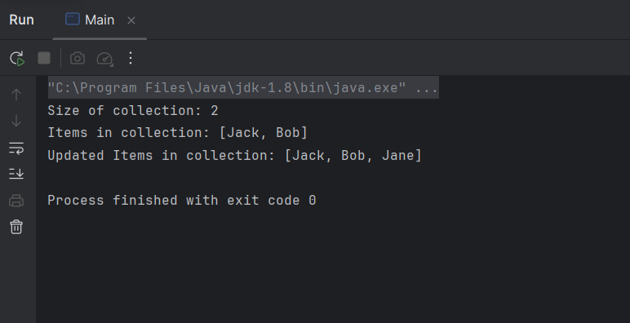

# Cases to use factory session pattern

## Task Management Application

**Scenario:**

A simple task management app where users can create, update, and delete tasks. Each user can have their own list of tasks, and they may need to interact with a database to store the tasks and their statuses (e.g., "To Do," "In Progress," and "Completed").

**When to Use Session Factory:**

In this case, the **Session Factory** pattern can be used to manage sessions when interacting with the database.

The Session Factory will:

* **Create a session** for each user when they interact with the application, allowing the user to perform CRUD operations (Create, Read, Update, Delete) on tasks.
* **Manage transactions**: For example, if a user adds a new task, marks it as completed, or deletes a task, the **SessionFactory** ensures that these operations are done within a single transaction, ensuring consistency.
* **Optimize session usage** by reusing session connections when users perform multiple actions, improving performance by reducing the overhead of opening and closing database connections repeatedly.

## Blog Management System

**Scenario:**

A simple blog platform where users can write posts, comment on posts, and manage their content. The system needs to interact with a relational database to store posts, user data, and comments. Multiple users may be interacting with the platform simultaneously, and the system needs to handle various database operations efficiently.

**When to Use Session Factory:**

In this case, the **Session Factory** can be used to manage the database sessions when handling blog posts, comments, and user data. The **Session Factory** will:

* **Create a session for each user request**, ensuring that their interactions with the database (e.g., creating a new blog post or fetching comments) are contained within that session.
* Ensure **transactions are properly managed**, so if a user creates a post, and multiple comments are made, the system ensures that all these operations are either committed together or rolled back in case of an error.
* Provide **a session pool** for efficient database access, so users don’t have to repeatedly open and close connections to the database. This improves performance, especially when there are multiple concurrent users.